In the world of interior design, the line is a fundamental element that profoundly influences the aesthetics and functionality of a space. Lines can define boundaries, create movement, and evoke emotions. Understanding how to use lines effectively can transform a room from mundane to extraordinary. This article delves into the different types of line, the significance of lines in interior design, and it provides practical ways to apply them for maximum impact.

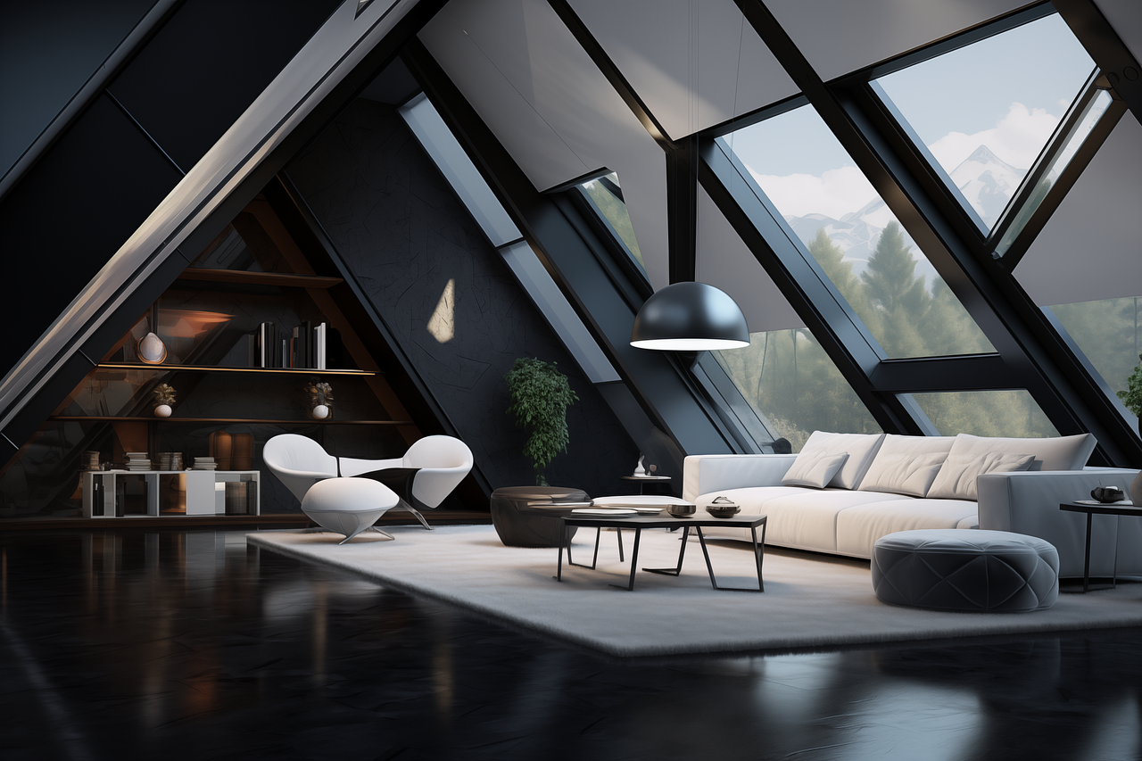

Fig. 1. Unsplash (n.d.) Open Plan room that uses line to define style

# Understanding the Role of Line in Interior Design

A line is more than just a mark between two points; it is a powerful tool that can guide the eye, shape the perception of space, and set the tone of a room. Lines in interior design can be categorised into straight and curved lines, each of which can be further divided into horizontal, vertical, and diagonal lines, each having a unique impact on a space.

## Straight Lines:

**Horizontal Straight Lines:** These lines run parallel to the ground and often give a sense of stability and calm. They are typically found in furniture like tables, shelves, and countertops. Horizontal lines can make a room appear wider and more spacious, contributing to a relaxed and grounded atmosphere.

**Vertical Straight Lines:** Running perpendicular to horizontal lines, vertical lines suggest height and strength. They are commonly seen in doorways, windows, and tall furniture like wardrobes and bookshelves. Vertical lines can make a room feel taller and more imposing, adding a sense of formality and grandeur.

**Diagonal Straight Lines**: Diagonal lines introduce movement and dynamism, creating a sense of action and direction. They can be used in architectural features, furniture arrangements, or decor to add visual interest and energy to a room.

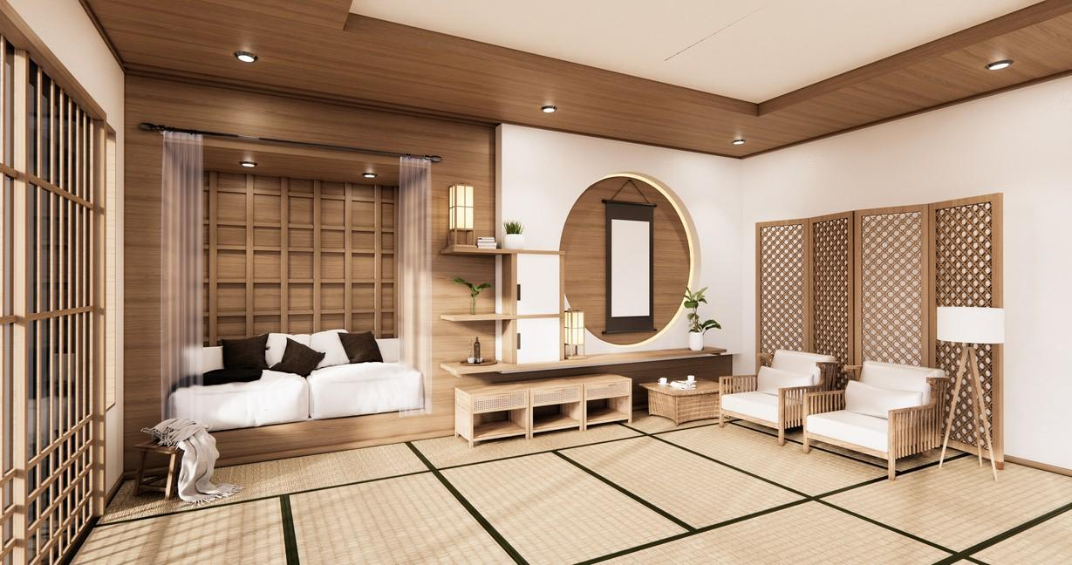

Fig. 2. Canva (n.d.), Interior Space with straight vertical and horizontal lines

## Curved Lines:

**Horizontal Curved Lines:** These lines run parallel to the ground but feature gentle arcs or waves, adding softness and tranquillity to a space. They are often found in elements like curved sofas or serpentine shelves, which can make a room feel more inviting and comfortable.

**Vertical Curved Lines:** Curved lines that run vertically can be seen in arched doorways or tall, curved-backed chairs. They add elegance and fluidity, emphasising height while softening the rigidity of straight vertical lines.

**Diagonal Curved Lines**: These lines introduce a sense of movement and organic flow, found in elements like spiral staircases or curved artwork. They can energise a space and draw the eye in a more dynamic and engaging way.

## Free-form lines:

Free-form lines introduce a sense of fluidity, creativity, and organic movement to a space. These lines, often found in abstract shapes, curves, or asymmetrical elements, break away from rigid structure, softening the overall ambiance and creating a more relaxed, dynamic environment.

**Implied lines:**

Implied lines are lines that guide the eye through a room without being explicitly drawn. They can be perceived in furniture elements, placement of objects, and in the form of the room itself, etc. They subtly influence the flow of movement. Implied lines play with perception, adding depth, interest, and emotional resonance to interior spaces.

# Practical Applications of Lines in Interior Design

Effectively incorporating lines into your design requires a balance of the different types to achieve the desired ambiance and functionality. Here are some practical tips and examples for using lines in interior spaces:

1. Creating Visual Interest with Horizontal Lines:

**Shelving**: Install open horizontal shelves on a wall to draw the eye across the room and make it feel wider. This is particularly effective in narrow spaces like hallways.

**Wall Treatments**: Horizontal stripes or panelling can elongate a room, making it feel more expansive. This technique works well in small rooms where you want to avoid a cramped feeling.

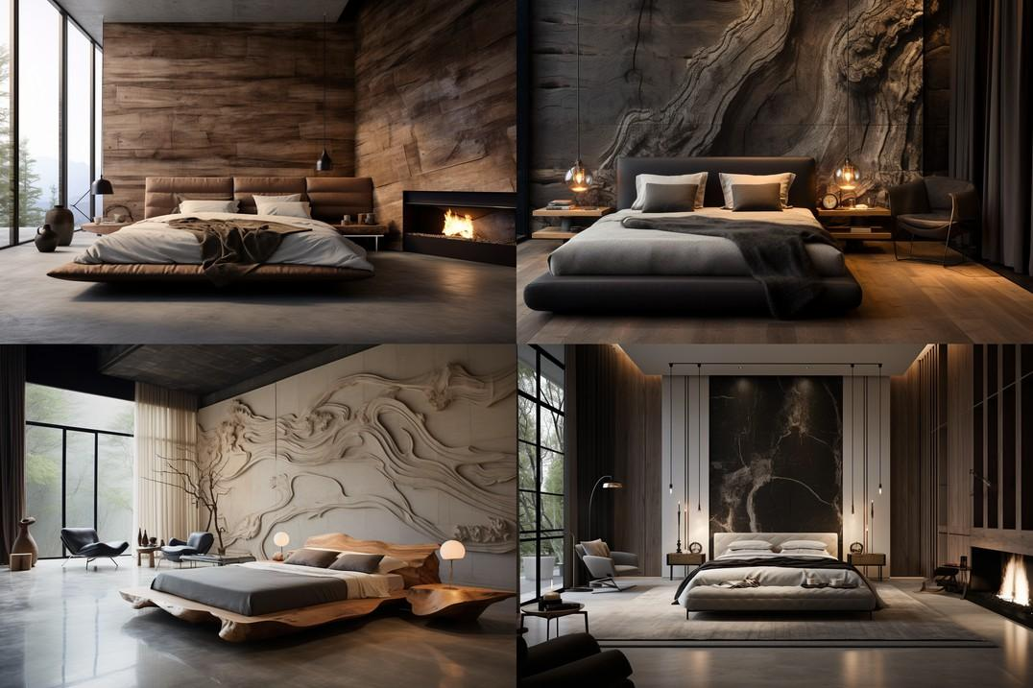

Fig. 3. Unsplash (n.d.): Different types of line applied in Interior Spaces.

1. Enhancing Height with Vertical Lines:

**Curtains and Drapes:** Hang curtains from ceiling to floor to accentuate the height of a room. This can make standard-height ceilings feel more lofty and luxurious.

**Tall Furniture:** Incorporate tall bookshelves or armoires to draw the eye upward, emphasising vertical space and creating a sense of elevation.

**Lighting**: Use pendant lights hung from the ceiling to a low level, in order to accentuate the height of the room (Fig. 3).

1. Adding Dynamism with Diagonal Lines:

**Furniture Placement**: Arrange furniture at angles rather than parallel to walls to introduce dynamic lines that guide movement and add interest. For instance, placing a sofa diagonally can break the monotony of right angles.

**Decorative Elements**: Diagonal lines in rugs or artwork can energise the space and create a focal point that catches the eye.

1. Softening Spaces with Curved Lines:

**Furniture Choices:** Use curved furniture pieces, like a round coffee table or an arched floor lamp, to soften the room and add a sense of flow and continuity.

**Architectural Features:** Incorporate elements like arched doorways or rounded corners to introduce gentle curves that create a more relaxed and inviting atmosphere.

# Combining Line Types for Balance and

Harmony

A well-designed room often incorporates a mix of line types to create balance and harmony. For example, a living room with a horizontally oriented sofa can benefit from vertical bookshelves to counterbalance the horizontal emphasis. Adding a round rug or curved armchair introduces a dynamic element, making the space feel cohesive yet lively.

Lines are an essential element in interior design, shaping the way we experience and interact with spaces. By understanding and thoughtfully applying horizontal, vertical, diagonal, and curved lines, you can enhance the aesthetics and functionality of any room. Whether you're aiming for a sense of tranquillity, of grandeur, or energy, lines can help you achieve your design goals. So next time you embark on a decorating project, pay attention to the lines around you and harness their power to transform your space.